Running Presentations with TurningPoint Remotes
Prior to you first training session, contact Paul Bloom (x4041) to get the remotes and make sure the TurningPoint software is installed and working on the computer/account from which you will be presenting. This configuration step is only required the first time you use TurningPoint on a new computer.
- Plug the transmitter into a USB port on the computer. | 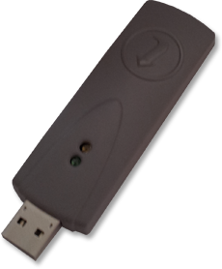
- Double-click the TurningPoint icon on the desktop. | 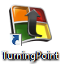
- You will see the TurningPoint application window popup. | 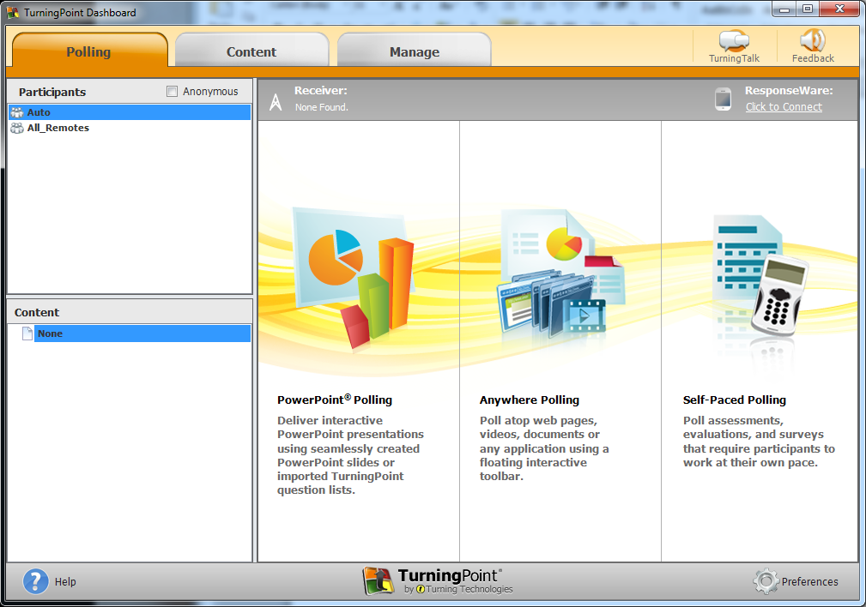
- Double-Click the PowerPoint Polling option.
- The PowerPoint application will launch with a new blank presentation. You will notice a new TurningPoint tab on the top right of the screen. | 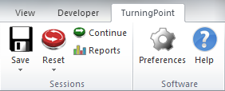
- At this point, you can load your own PowerPoint presentation with the polling features enabled. Continue with your PowerPoint presentation as you would any other.

When you are done
- Once you have finished your presentation, you may wish to reset the audience responses and charts. Click the Reset button on the TurningPoint tab in PowerPoint to do so.
- Count the remotes to be sure there are 30 total, and remove the USB transmitter from the presentation computer. Place these items into the TurningPoint travel case.
- Immediately return the travel case to either:
  - Scott Mangold, B24 - R233, x4295
  - Nancy Qatsha, B28 – R118, x2676

Installation of TurningPoint
The TurningPoint software should already be installed on the training room computer. It may need to be configured to work with your user account the first time you use it. Contact Scott Mangold (x4295) for help.
To install the most recent version of TurningPoint on a different system, go to the TurningTechnologies download site. Go to Polling Software > TurningPoint > PC – No Install Version. You do not need administrative privileges to install this version of the software.

